**Sport Science Physiology Simulation Design Document**

# High Concept

Application designed to be used as a teaching aid that is programmed to simulate the physiological responses of the human body when using sports science equipment.

# Team Roles

**Producer**

* Emily Salisbury

**Code**

* Sam Hunt
* Alex Marshall
* Conor Burke

**Art**

* Georgie Phimister

**Design**

* Bethany White
* Alex Vaughan

# Notes & Considerations

* Accessibility for students (available online) - eligible for those unfamiliar with games
* Change variables mid-simulation to see changes take effect
* View changes on the body/inform the user of the effects on the body
* Optional safety warnings/alarms
* Resizeable for different resolutions
* Text size options - accessibility

# Application Overview

###### Description

A 2D virtual lab to be used as a teaching aid for Sports Science students. The application should allow the user to select at least 4 sports lab equipment, including a treadmill, exercise bike, rower and a swimming flume, and be able to view a simulated humans reactions when they are using the equipment. The user can change variables that determine age, weight and height of the simulated human, which will impact the rate of some of the variables being output from the simulation. Additionally, the user will be able to change variables that determine the environment of the simulation, including humidity, temperature and oxygen level. The last variables that can be changed are specific to the equipment that is in use. For example, if the user selected the treadmill module, they would be able to alter the gradient, speed and duration for different effects on the data being output by the simulation. The user will be able to view the physiological data being output from the simulated human in the form of figures (graphs), numbers or as both.

###### Objectives

* Accurately simulate physiological responses to the human body according to variables set either by the application (Random or Default) or the user.
* View the relevant corresponding data to these simulations in table/graph form.
* Allow the user to change which variables are being viewed, and to change the values of certain variables mid-simulation, such as speed, duration, etc.
* Give the option of at least 4 modules including bike, treadmill, rower and swimming flume.

###### Stretch Goal Objectives

* Exam mode/Functionality for assessment purposes (needs further discussion with client)
* Safety warnings/alarms at dangerous levels
* Database for a login function
* Additional modules and more of the equipment being visually represented
* Animation of the character using the equipment
* Sound effects for the animation and UI

###### Target Audience

Sports Science Students & Faculty

###### Platform

Target is to develop a standalone application (.exe) for PC.

* MAC Compatibility?

# Application Mechanics

User will be able to select exercise equipment as seen on the screen. This will enable them to be able to select individual monitoring equipment or ‘modules’ (defined by a particular group of variables, eg cardiovascular or pulmonary variables).

Modules include all of the relevant variables to that type of data. Users will be able to select multiple modules to view at the same time but will never be able to view all of them at once. Once a module has been selected, the user will be able to remove specific variables from being viewed if they wish.

If selecting individual monitoring equipment, users will then be able to view the relevant variables measured by that type of equipment. Users can select multiple equipment apparatus as appropriate and select which of these variables they wish to view.

# **Gameflow**

# Controls

Mouse - point and click

Keyboard - Input data & variables

# 

# Screen Layout

### In-Application UI

Early In-Application UI Concept 1

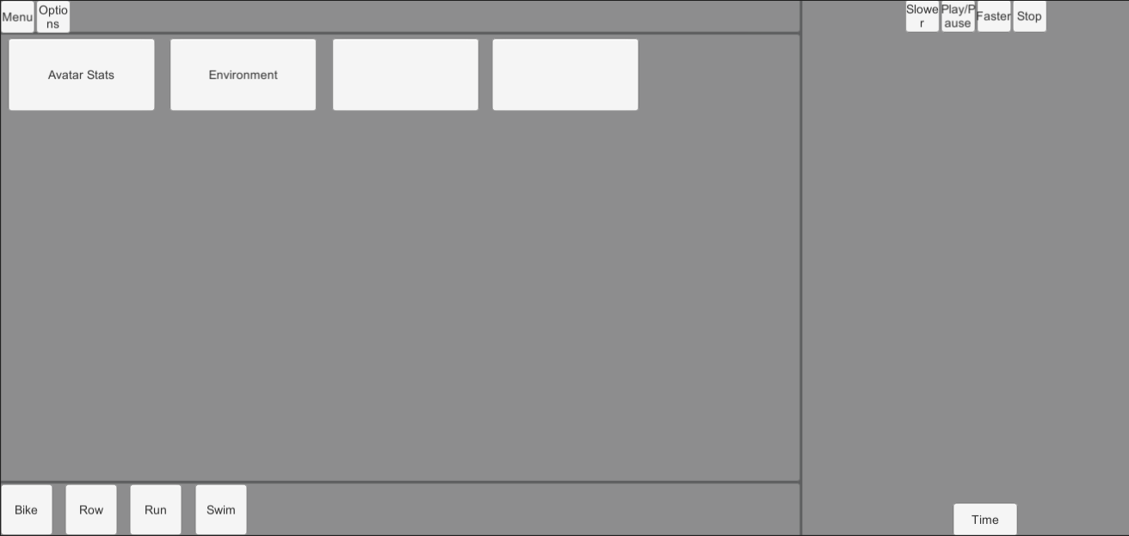

Early In-Application UI Concept 2

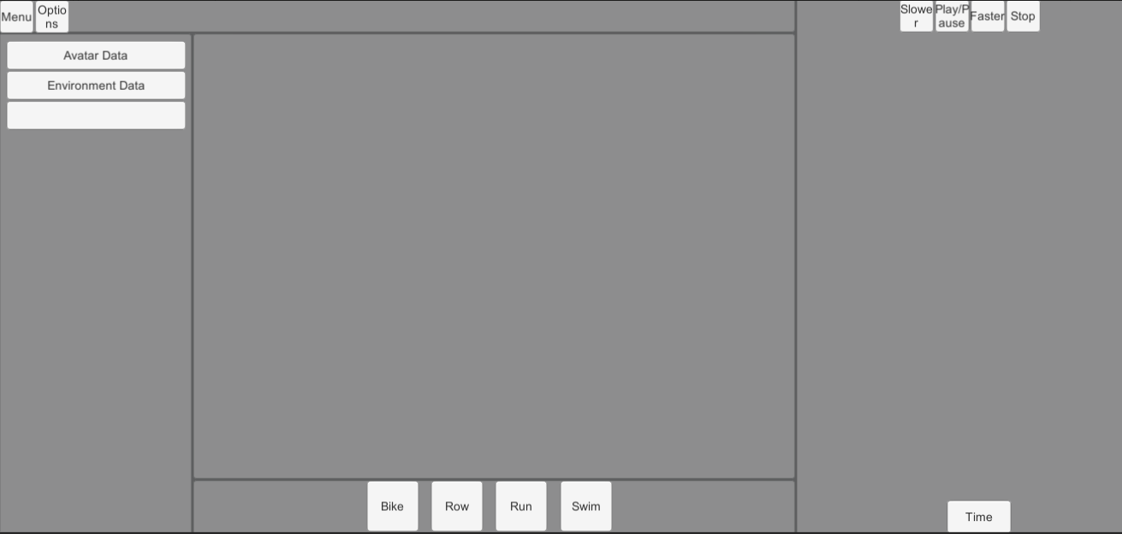

Early In-Application UI Concept 3

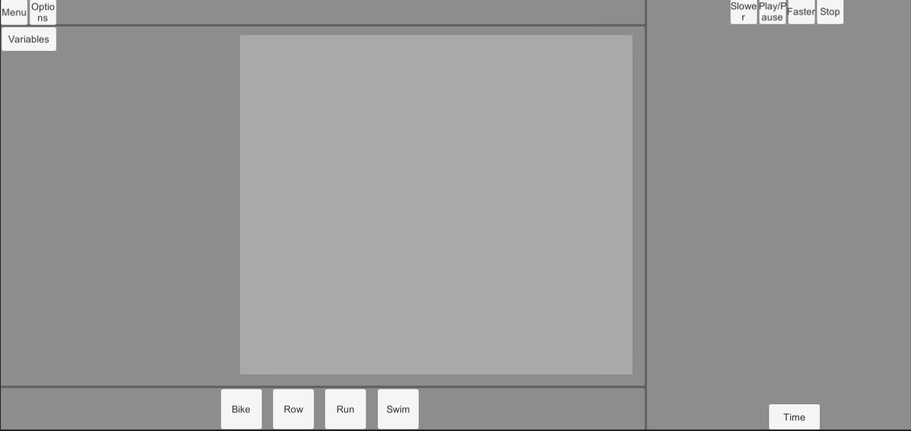

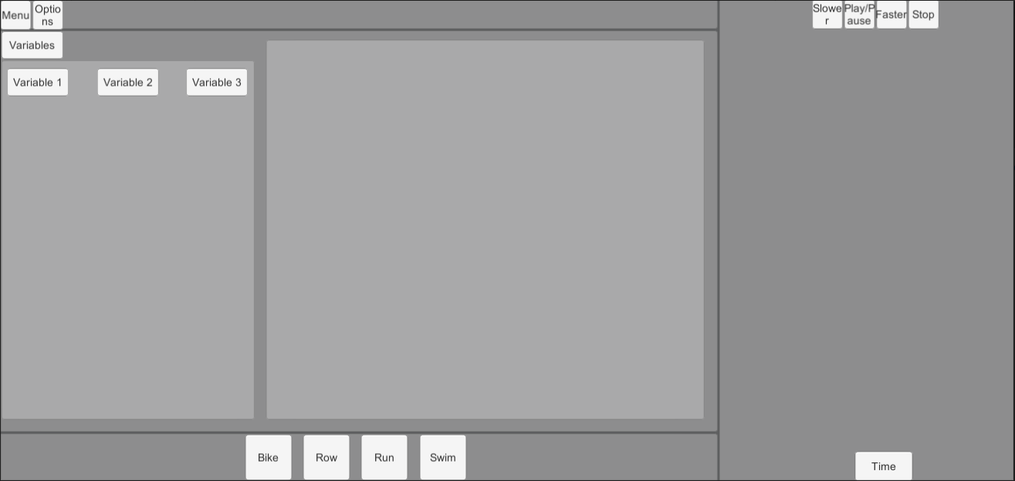

Early In-Application UI Concept 4

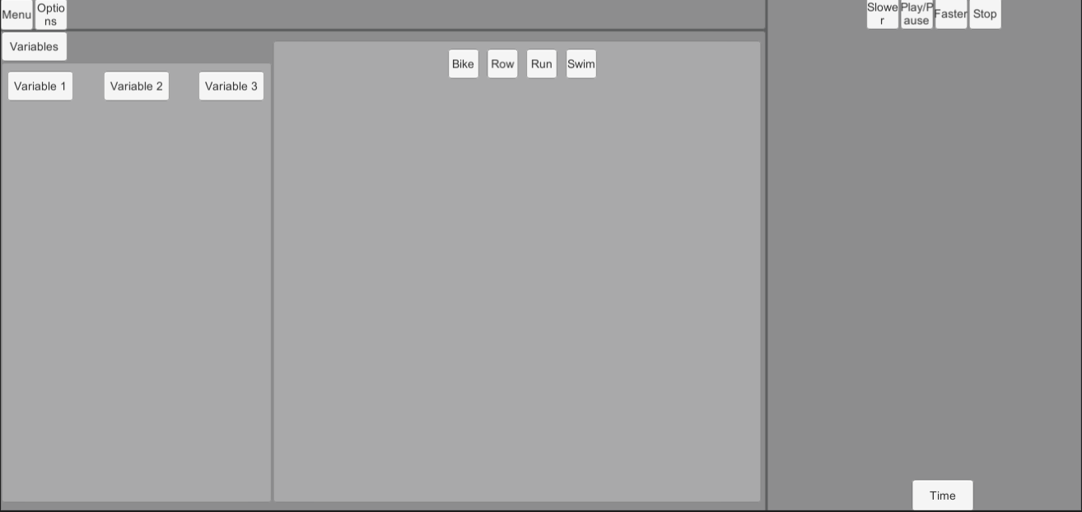

Early In-Application UI Concept 5

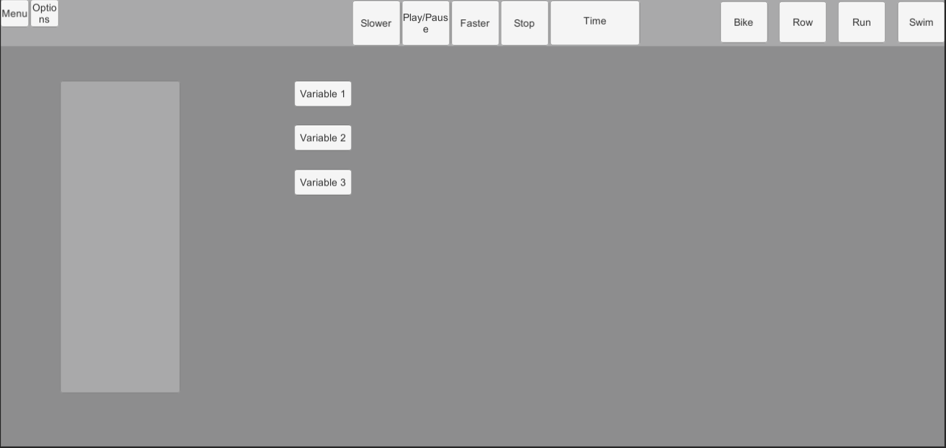

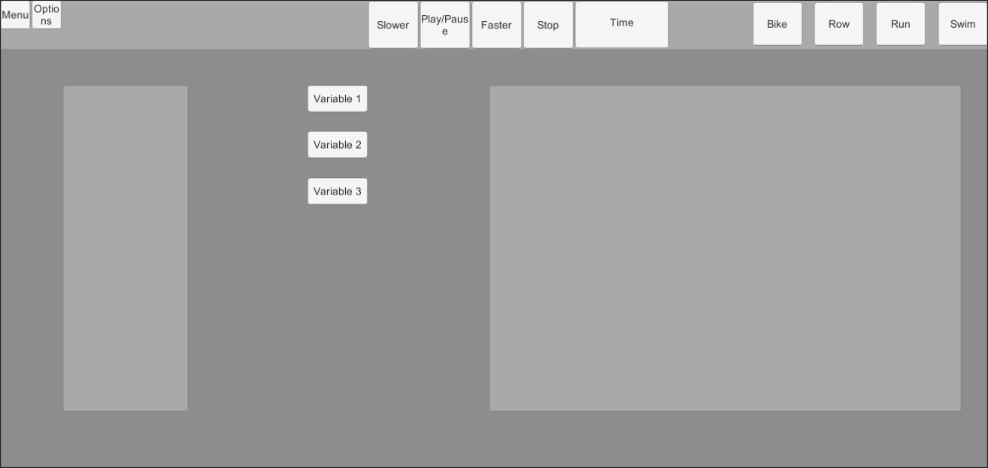

Early In-Application UI Concept 6

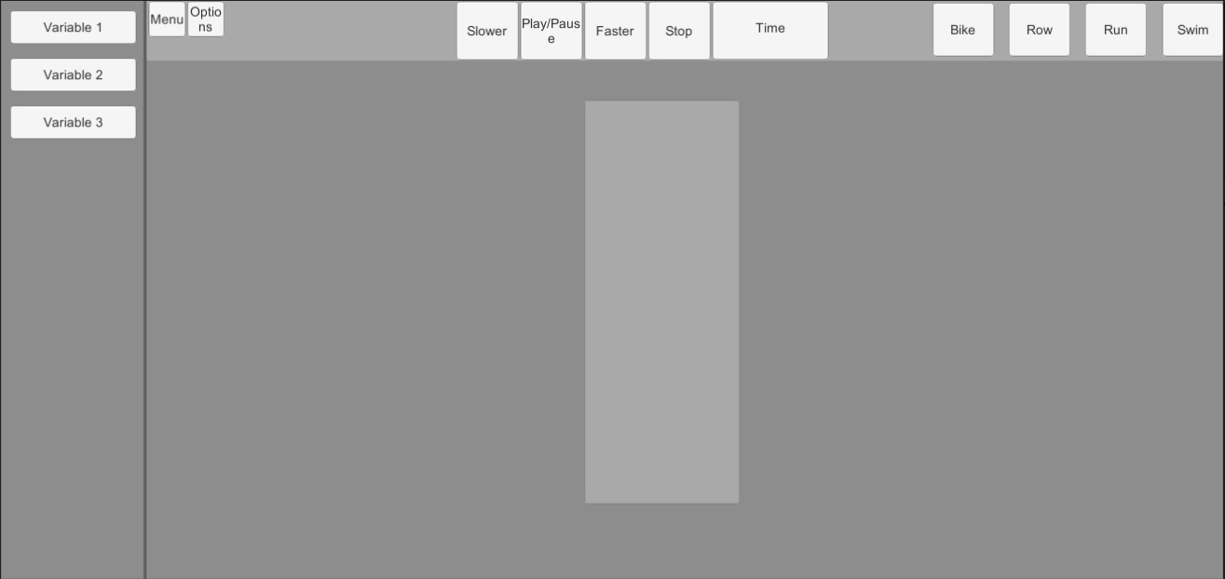

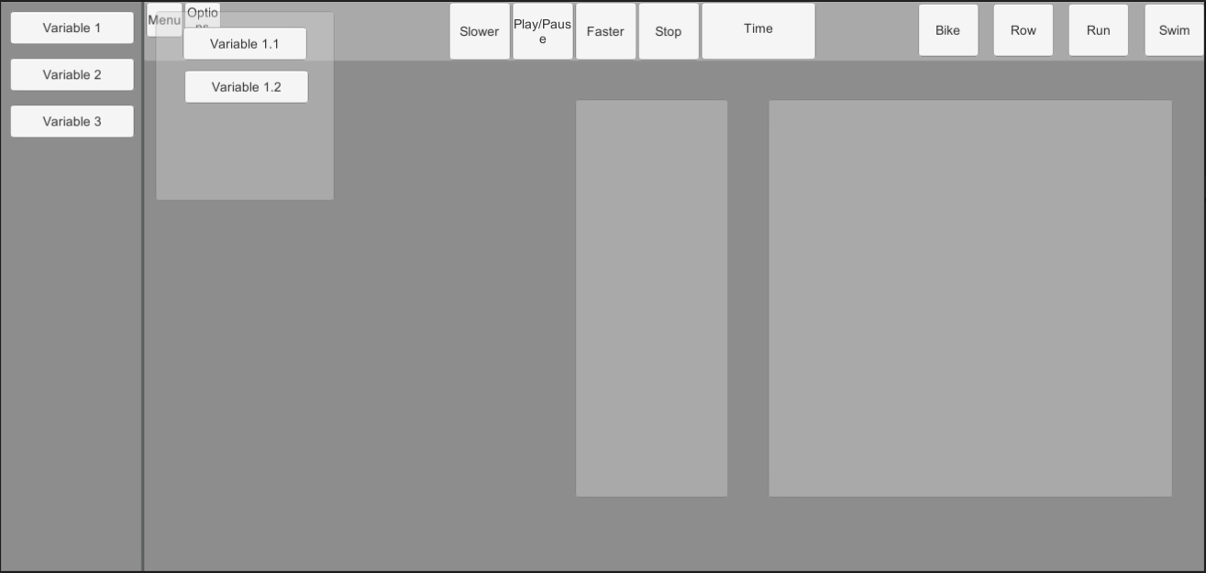

### Start Menu UI

### Options UI

# Walkthrough

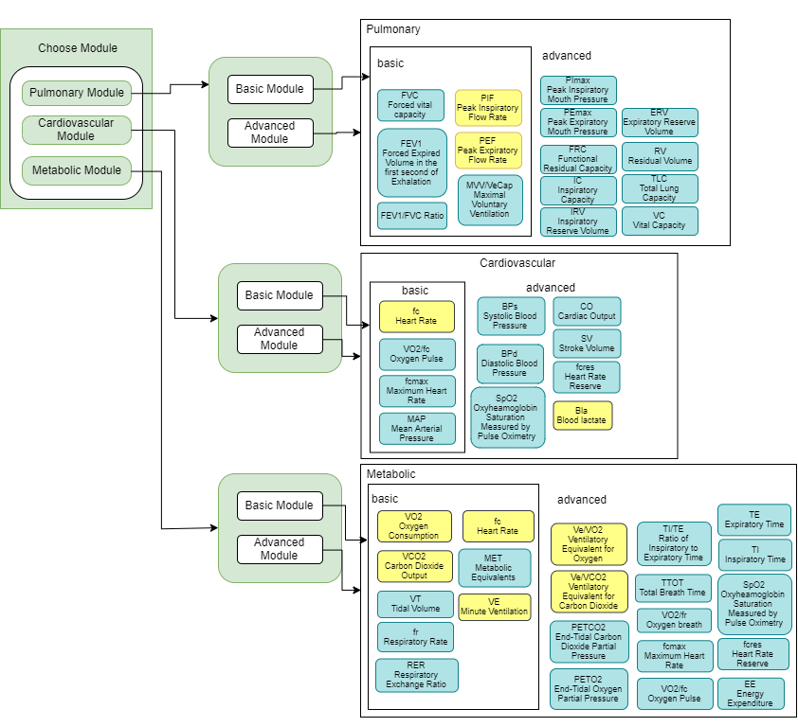

##### 

# Variables

**Model Variables**

Age, Weight, Height, Sex, Race - Options for random/default and manually set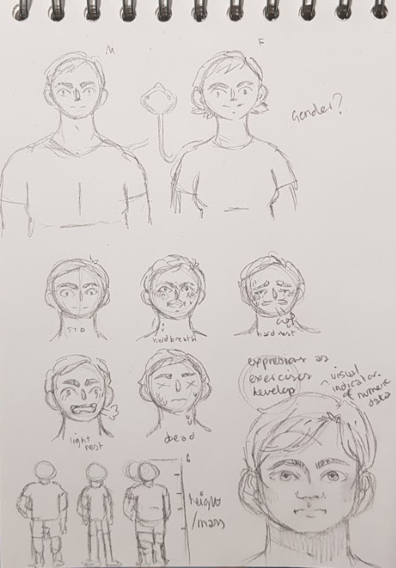

### Environment Variables

Temperature, Humidity, Oxygen Level - Options for random/default and manually set

### Equipment Variables

**Bike**

Wattage, Cadence, Duration - Options for default or manually set

**Rower**

Strokes per Minute, Wattage, Duration - Options for default or manually set

**Swimming Flume**

Velocity, Duration - Options for default or manually set

**Treadmill**

Gradient, Speed, Duration - Options for default or manually set

### Output Variables

* STPD
* Work Rate - *Text & Figures Displayed*
* Energy Expenditure
* Blood Pressure Machine (BPS)
* Douglas Bags
* Blood Lactate Glucose
* Height
* Forced Vital Capacity
* Forced Expired Volume
* Body Mass
* Speed
* Time
* Oxygen
* Humidity
* BTPS
* Air Temperature
* ATPS
* Diastolic Blood Pressure
* Systolic Blood Pressure
* Oxygen Pulse
* Mean Arterial Pressure
* Maximum Heart Rate
* Heart Rate - *Text & Figures Displayed*
* CO2 Output
* Excess Post-exercise oxygen Consumption (EPOC)
* End-tidal CO2 Partial Pressure
* End-tidal O2 Partial Pressure
* Expiratory Time
* Fractional Concentration of Expired CO2/O2
* Fractional Concentration of inspired CO2/O2
* Inspiratory Time
* Maximal Oxygen Uptake
* Minute Ventilation - *Text & figures Displayed*
* Metabolic Equivalents (MET)
* Oxygen Breath
* Oxygen Consumption - *Text & Figures Displayed*
* Oxyhemoglobin Saturation Measured by Pulse Oximetry
* Peak Oxygen Uptake
* Rate of Inspiratory to Expiratory Time
* Respiratory Exchange Ratio
* Respiratory Quotient
* Respiratory Rate
* Tidal Volume
* Total Breath Time
* Ventilatory Capacity
* Ventilatory Equivalent for O2 - *Text & Figures Displayed*
* Ventilatory Equivalent for CO2 - *Text & Figures Displayed*
* FEV1/FVC Ratio
* Water Vapour Pressure (PH2O)

**Lab Equipment List**

* Arm Crank Ergometers

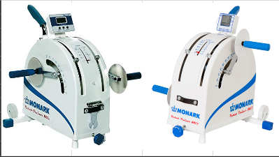

* Blood Pressure Machine
* Cycle Ergometers (Wingate & Electronically Braked)

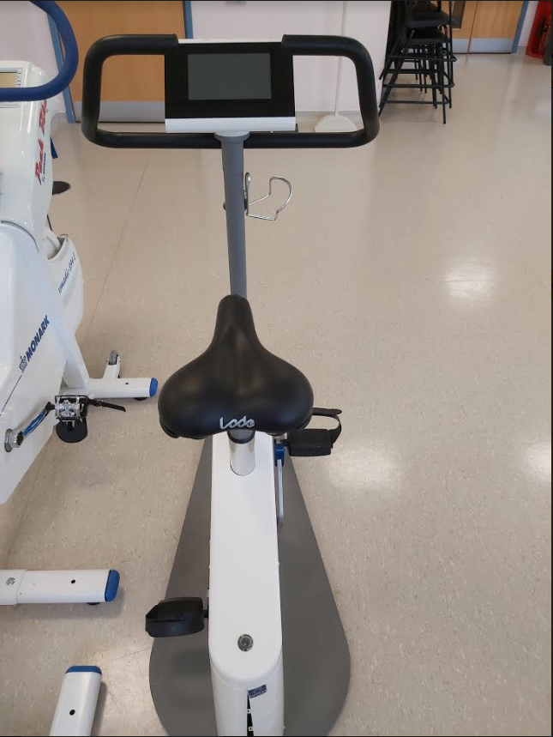

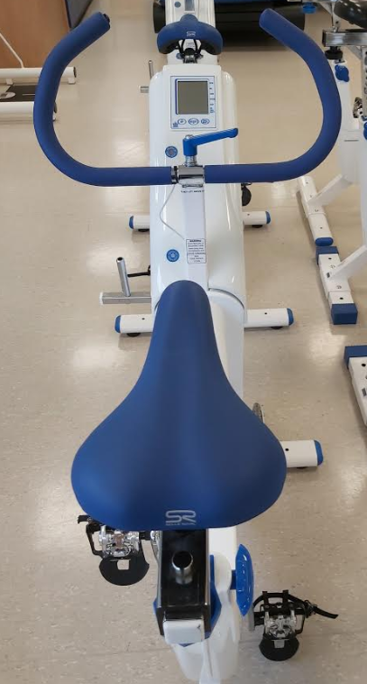

* Douglas Bags

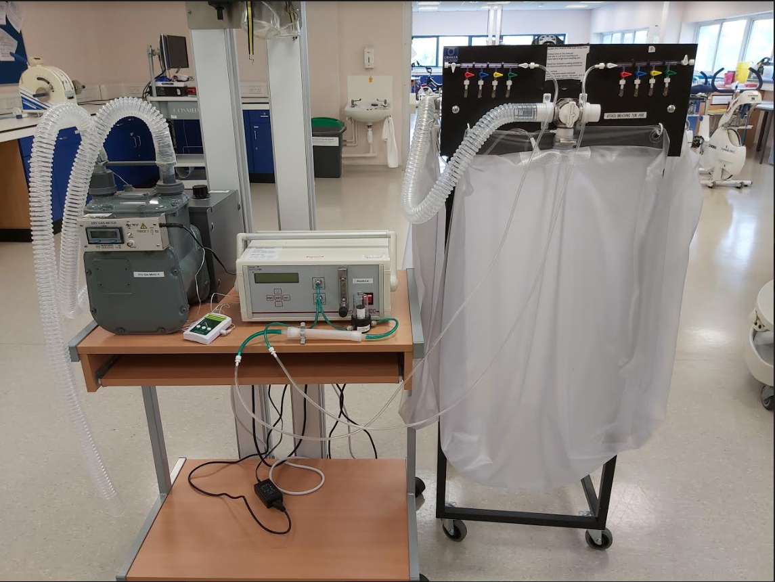

* Dry Gas Meters



* Gas Analysers



* Heart Rate Watches & Transmitter Belts
* Blood Lactate & Glucose Analyser

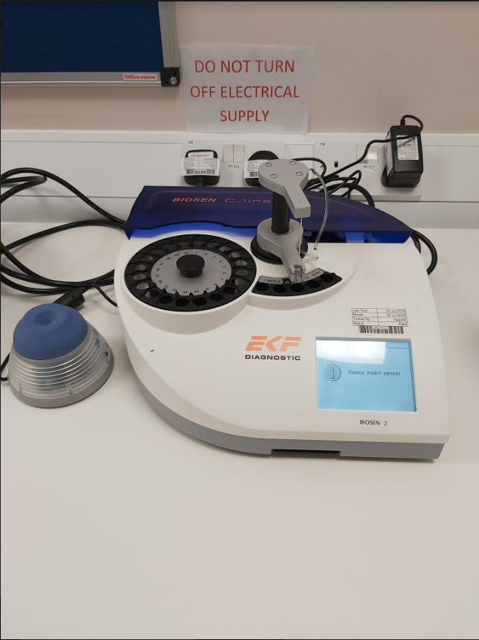

* Masks (Oro-Nasal)

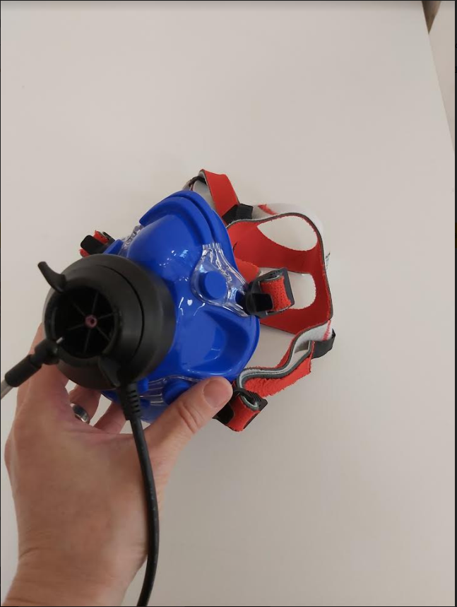

* Metabolic Carts
* Mouth Pieces
* Nose Clips

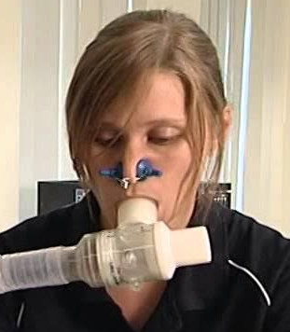

* Respiratory Tubing
* Rowing Ergometers
* Spirometer
* Stadiometer
* Stop Cock Valves
* Stop Watch

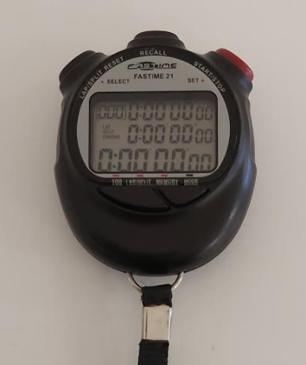

* T-Shape Non-Rebreathing Valve
* Treadmills

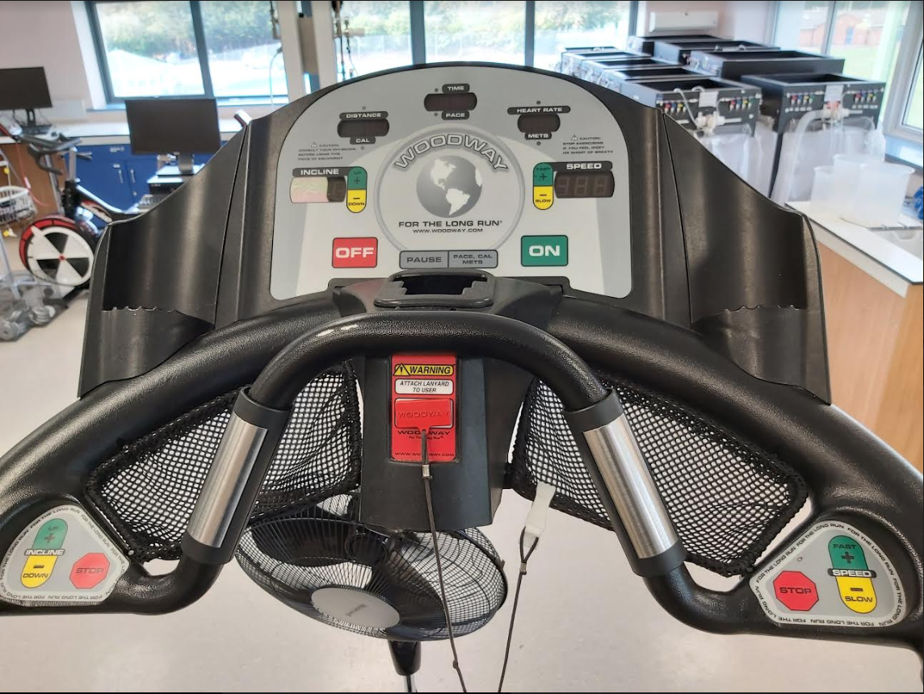

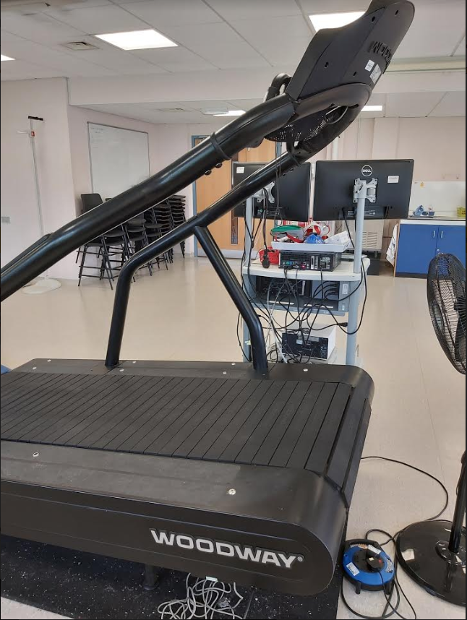

* Weighing Scales

# Art

**Art Asset List**

**Characters:**

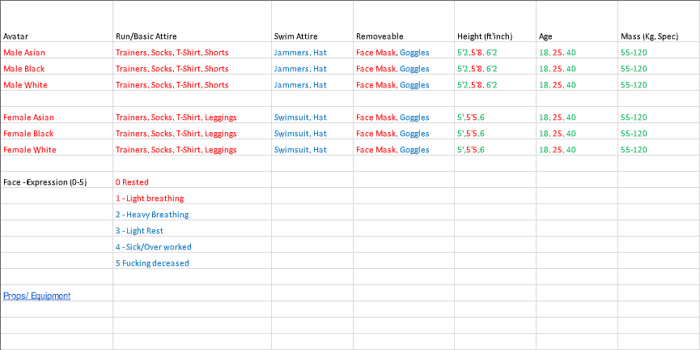

|  |  |  |  |  |  |
| --- | --- | --- | --- | --- | --- |
| **Equipment:** |  |  |  |  |  |
| alcohol wipes | dynamometer | laser doppler probe | rowing ergometers | t-shape non-rebreathing valve | enviro. control panel |
| anthropometry tape | electrocardiograph | masks (oro-nasal) | skin calipers | thermometers | fans |
| arm crank ergometers | electrical stimulator | mass spectrometer | skin electrodes | thermisters (skin, rectal) | filing cabinets |
| back dyananometer | gas anlaysers | medical pen | sit & reach box | tissues | first aid kit & defibrilator |
| bacterial filters | gas sampling port | metabolic carts | snorkel | treadmills | freezer |
| blood pressure machine | gauze | metronome | spirometer | weighing scales | ice |
| bottled gas | hand grip dyanometer | mouth pieces | stadiometer | & bioelectrical impedence analysis | medical couch |
| calculator | heart rate watches & transmitter belts | needles | stairmaster | wireless forecast station | phelbotomy chair |
| catherters | hydrostatic weighing | nose clips | stop cock valves | **Background / Building** | sharps bin |
| counters | jump meter (digital) | pulse oximeters | stop watch | bin | tables |
| cycle ergometers (Wingate | lactate & glucose anlayser | Q-sweet | syringe (calibration) | chairs | telephone |
| & electronically braked) | lancets | respiratory muscle trainers | syringes (blood) | clock | white board |
| douglas bags | laptops | respiratory pressure meter | swimming flume | clinical waste bin |  |
| dry gas meters | laser doppler perfusion & temp. monitor | respiratory tubing | tablet e.g.ipad | cupboards for storage |  |

**Art Style**

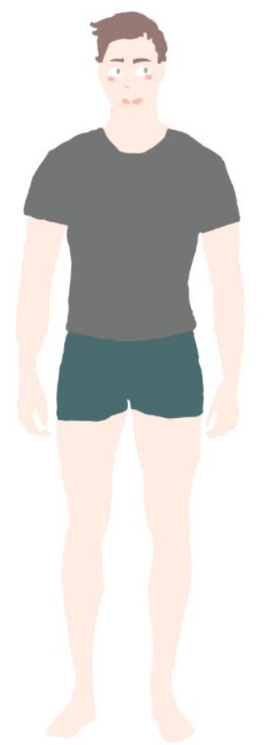 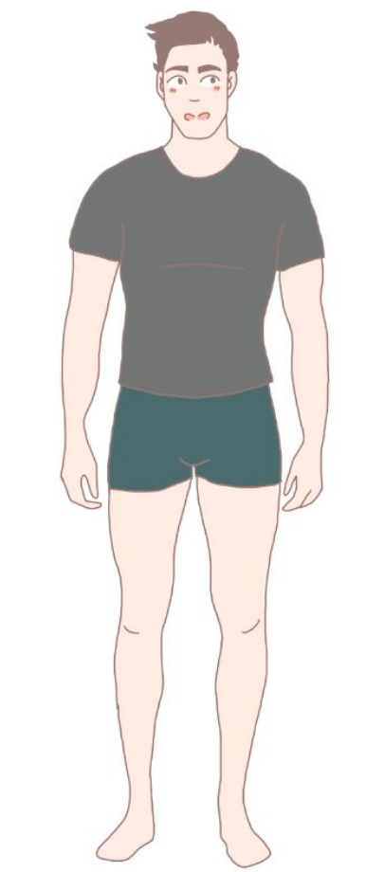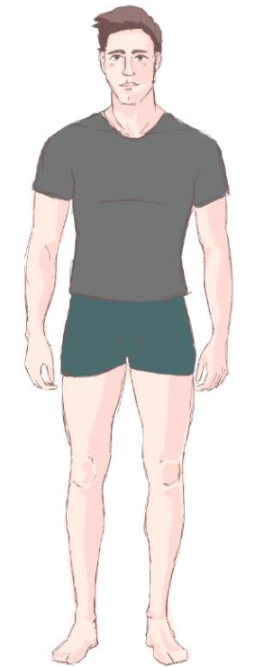

Character Art Style 1 Character Art Style 2 Character Art Style 3

Art style 3 was selected. This style is the easiest to replicate for non-art team members as it requires no fine lines and minimal artistic skill, being very forgiving with the “sketchy” lines. Process involves finding a suitable reference image, lowering opacity and tracing the object. Minimal shading (only for the base colour of the asset) for dimension and speed of production, with light coming from the top left angle.. Brush use in lining is “hard round” 100% hardness/opacity in size 4, colour as R45 G28 B26 H7 S43 B18

All characters to use same clothing and colour palettes of the clothing, equipment assets to use shared colour palette for same colours i.e 1 blue and dark blue tone for shading. Colour used to represent black won’t have a darker “shade” tone as this will contrast too highly with the outline, and black will also be used for metallics. No text on any assets - block colour to be used to replicate text position instead to ensure no breach of copyright and easier reproduction for other team members.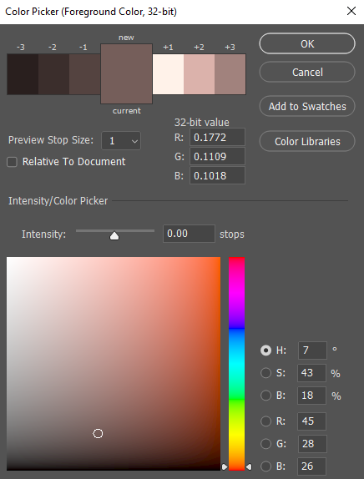

##### 

# Programming

# 

# Sound

# Stress Test

# User Testing & Prototyping

# Comparative Applications

* Labster-Exercise Physiology - <https://www.labster.com/simulations/exercise-physiology/>
* Pulse Physiology Engine - <https://physiology.kitware.com/>
* Virtual Physiology - <http://www.virtual-physiology.com/>
* Bio Gears - <https://www.biogearsengine.com/>

# Technology

**Art**

Adobe Photoshop

**Code**

Unity - An industry standard software that allows the possibility of progressing the software further into a 3D application if the project is worked on further.

**Version Control**

GitHub - It is a free and widely known form of version control that connects well with unity, allows everyone easy access and safely works with the code and art assets.

**Team Communication**

Trello - Gives clear visuals of objectives, in different stages of completion, that are viewable by the entire team.

Discord - Allows simple communication between a group of people and has the capability of voice chat if needed.

Production time frame

(Can each member of the team outline their tasks along with estimated times for completion, assuming best conditions)

**Code**

Sam Hunt

Alex Marshall

Conor Burke

**Art - Characters**

Character draft/defining art style: 1-3hr

Collecting reference images: 1hr

Character Assets w/ singular outfit: 4-6hr

Character Assets w/ both outfits and mask: 3-4hr

Alternative Facial Expressions per tier: 3-4hr

Converted Character Assets into PNG: 1hr

**Art - Equipment (inc. background)**

Collecting reference images: 1hr

Outline of all red assets: 5-10hr

Colour and shading of all red assets: 10-15hr

Converting all red assets to PNG w/ and w/o outline:1-2hr

Draft Background: 1hr

Completed Background: 1-3hr

Outline of all blue assets:

Colour and shading of all blue assets:

Converting all blue assets to PNG w/ and w/o outline:

Outline of all green assets:

Colour and shading of all green assets:

Converting all green assets to PNG w/ and w/o outline:

**Design**

Bethany White

Alex Vaughan

# References